AIM:
To write a C program to perform lexical analysis of a given C statement and identify the tokens as keywords, identifiers, constants, operators, and special symbols.
ALGORITHM:
- Start the program.
- Declare an array containing all the C keywords.
- Read a C statement from the user.
- Scan the input statement character by character.
- Ignore white spaces.
- If the character is a letter or underscore, read the complete word.
- Check whether the word is a keyword.
- If yes, identify it as a Keyword.
- Otherwise, identify it as an Identifier.
- If the character is a digit, read the complete number and identify it as a Constant.
- Check for arithmetic operators such as +, -, *, /, %.
- Check for relational and assignment operators such as =, <, >, ==, <=, >=.
- Check for special symbols such as (, ), {, }, [, ], ;, and ,.
- If the character does not belong to any category, identify it as an Unknown Symbol.
- Display each token along with its corresponding category.
- Stop the program.
PSEUDO CODE:
BEGIN
1. Declare the input string.
2. Store all C keywords in an array.
3. Read the C statement from the user.
4. Set i = 0.
5. Repeat until the end of the input:
a. If the current character is a white space,
skip it.
b. If the current character is a letter or '_':
i. Read characters until a non-alphanumeric
character is found.
ii. Store the word.
iii. Check whether the word is a keyword.
iv. If it is a keyword, display "Keyword".
v. Otherwise, display "Identifier".

c. Else if the current character is a digit:
i. Read the complete number.
ii. Display it as "Constant".
d. Else if the current character is '+', '-', '*',
'/', or '%':
i. Display it as "Arithmetic Operator".
e. Else if the current character is '=', '<', or '>':
i. Check the next character.
ii. If it is '=', display it as "Relational Operator".
iii. Otherwise, display it as "Operator".
f. Else if the character is '(', ')', '{', '}', '[',
']', ';', or ',':
i. Display it as "Special Symbol".
g. Otherwise:
i. Display it as "Unknown Symbol".
6. Increment i whenever required.
7. Display all identified tokens.
END
CODE:
#include <stdio.h>
#include <string.h>
#include <ctype.h>

int isKeyword(char str[])
{
char keywords[][20] = {
"auto", "break", "case", "char", "const",
"continue", "default", "do", "double",
"else", "enum", "extern", "float", "for",
"goto", "if", "int", "long", "register",
"return", "short", "signed", "sizeof",
"static", "struct", "switch", "typedef",
"union", "unsigned", "void", "volatile",
"while"
};

int i;

for (i = 0; i < 32; i++)
{
if (strcmp(str, keywords[i]) == 0)
return 1;
}

return 0;
}

int main()
{
char input[1000];
int i = 0;

printf("Enter a C statement:\n");
fgets(input, sizeof(input), stdin);

while (input[i] != '\0')
{
/* Ignore white spaces */
if (isspace(input[i]))
{
i++;
continue;
}

/* Identifier or Keyword */
if (isalpha(input[i]) || input[i] == '_')
{
char word[50];
int j = 0;

while (isalnum(input[i]) || input[i] == '_')
{
word[j++] = input[i++];
}

word[j] = '\0';

if (isKeyword(word))
printf("%s\t\tKeyword\n", word);
else
printf("%s\t\tIdentifier\n", word);
}

/* Number */
else if (isdigit(input[i]))
{
char number[50];
int j = 0;

while (isdigit(input[i]) || input[i] == '.')
{
number[j++] = input[i++];
}

number[j] = '\0';

printf("%s\t\tConstant\n", number);
}

/* Arithmetic Operators */
else if (input[i] == '+' || input[i] == '-' ||
input[i] == '*' || input[i] == '/' ||
input[i] == '%')
{
printf("%c\t\tArithmetic Operator\n", input[i]);
i++;
}

/* Relational / Assignment Operators */
else if (input[i] == '=' || input[i] == '<' ||
input[i] == '>')
{
if (input[i + 1] == '=')
{
printf("%c%c\t\tRelational Operator\n",
input[i], input[i + 1]);
i += 2;
}
else
{
printf("%c\t\tOperator\n", input[i]);
i++;
}
}

/* Special Symbols */
else if (input[i] == '(' || input[i] == ')' ||
input[i] == '{' || input[i] == '}' ||
input[i] == '[' || input[i] == ']' ||
input[i] == ';' || input[i] == ',')
{
printf("%c\t\tSpecial Symbol\n", input[i]);
i++;
}

/* Unknown Symbol */
else
{
printf("%c\t\tUnknown Symbol\n", input[i]);
i++;
}
}

return 0;
}
INPUT:
Enter a C statement:
int a = 10 + b;
OUTPUT:
int Keyword
a Identifier
= Operator
10 Constant
+ Arithmetic Operator
b Identifier
; Special Symbol
OUTPUT: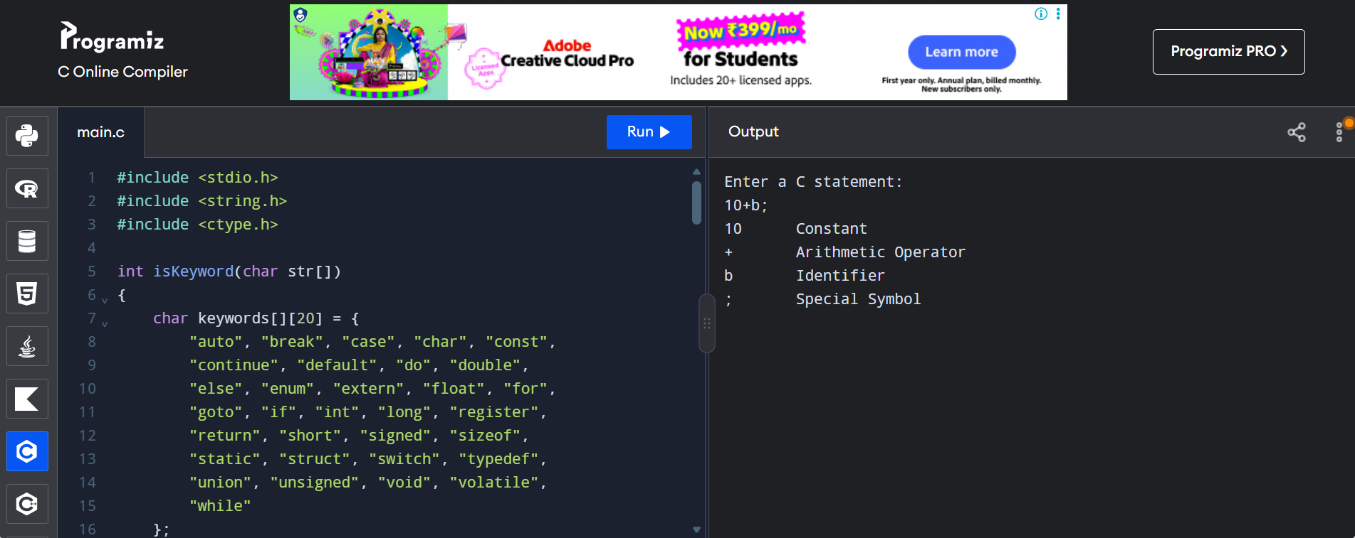
RESULT:
Thus, the C program for lexical analysis was successfully executed, and the given C statement was analyzed to identify keywords, identifiers, constants, operators, and special symbols.

